Requirements Document

Project: [Project name]
Organization: [Organization name]
Author: [Author’s name and title; add organization if relevant]
Date: [Date published]
Version: [Version number]

Document Versions

Version  Number | Date  Published | Author | Summary of  Changes
[Unique identifier for the document version] | [Date document was distributed to stakeholders] | [Author of the version] | [Overview of changes made since the previous version. If this is the first version, you can simply say so.]

Table of Contents
Document Versions 2
Stakeholders 3
Project Overview 3
Assumptions and Unknowns 3
Business Requirements 3
User Requirements 3
Functional Requirements 3
Nonfunctional Requirements 3
[Category] 3
[Category] 3
[Category] 3
Diagrams and Models 3
User Interface 3
Special Considerations 3
For Development 3
For Testing 3
For Implementation 3
For Training 3

Stakeholders

Name | Functional  Role | Requirements  Role | Version & Date  Approved
[Stakeholder’s name] | [Role of stakeholder within organization or project] | [One of following:  Author,  Approver,  Reviewer] | [Version number and date stakeholder provided approval. “N/A” if stakeholder is not an approver]

Project Overview

[This section typically contains the following components:
- Brief description of the project
- Why it’s being executed
- Goals for the project
- Success criteria
...but feel free to use whatever works best for your project/organization.]

Assumptions and Unknowns

ID | Description | Assigned To | Status with Due Date
[Unique identifier for the assumption or unknown] | [Description of the item] | [Name of the person to whom the item is assigned] | [Status of the item with the date it is targeted to be resolved]

Business Requirements

Req ID | Requirement | Rationale | Source
[Unique ID for the requirement] | [Description of the requirement itself] | [Reason why the requirement is necessary or desired] | [Name and role of the person providing the requirement]

User Requirements

Req ID | Requirement | Rationale | Source | Parent
[Unique ID for the requirement] | [Description of the requirement itself] | [Reason why the requirement is necessary or desired] | [Name and role of the person providing the requirement] | [Unique ID for the parent requirement]

Functional Requirements

Req ID | Requirement | Rationale | Source | Parent
[Unique ID for the requirement] | [Description of the requirement itself] | [Reason why the requirement is necessary or desired] | [Name and role of the person providing the requirement] | [Unique ID for the parent requirement]

Nonfunctional Requirements

[Category]
Req ID | Requirement | Rationale | Source | Parent
[Unique ID for the requirement] | [Description of the requirement itself] | [Reason why the requirement is necessary or desired] | [Name and role of the person providing the requirement] | [Unique ID for the parent requirement]

[Category]
Req ID | Requirement | Rationale | Source | Parent

[Category]
Req ID | Requirement | Rationale | Source | Parent

Diagrams and Models

[NOTE: This section should be customized to your project, based on which diagramming and modeling methods you use.
We suggest also titling the images and placing any brief relevant commentary prior to the image.
Many examples follow.]

Flowchart describing the logon process
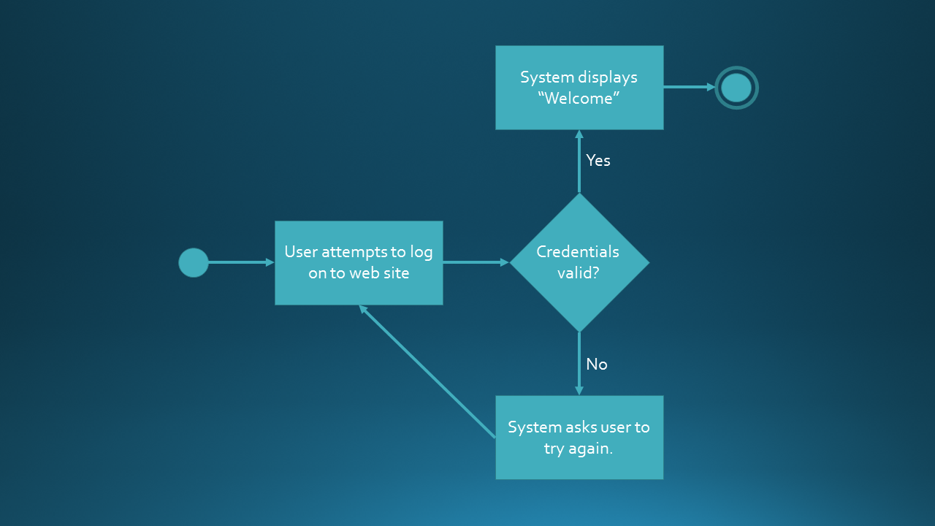

Swim lane flowchart describing the account opening process.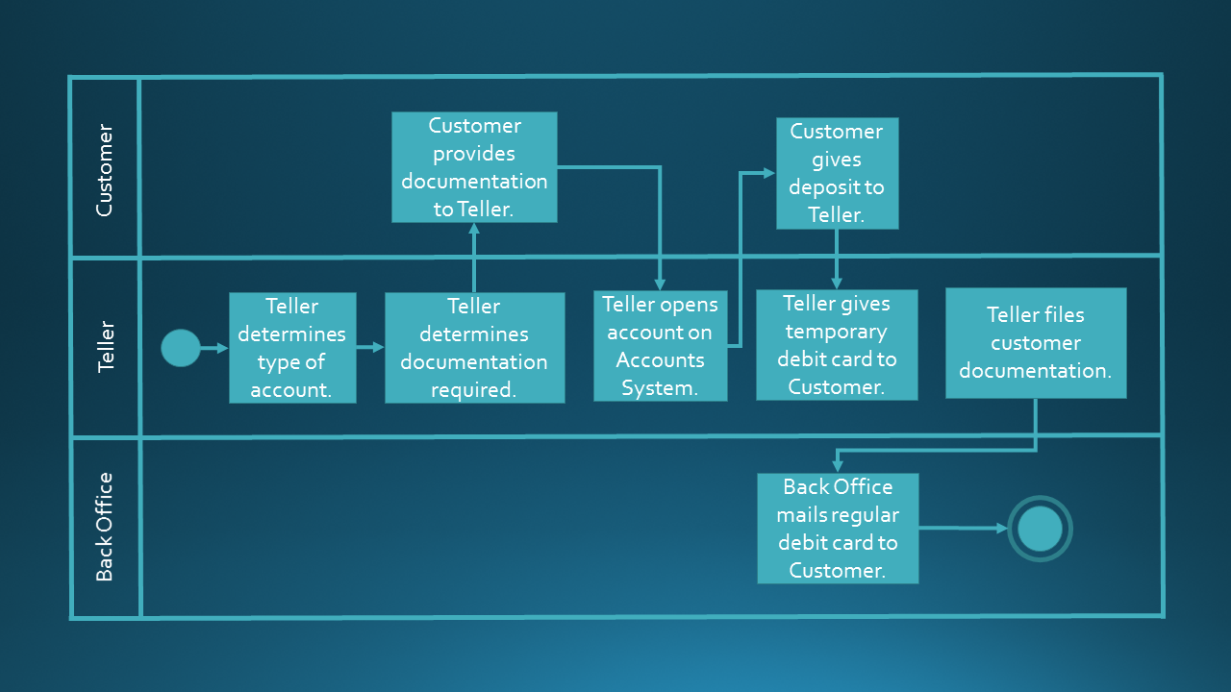
State-transition diagram for the “request” object.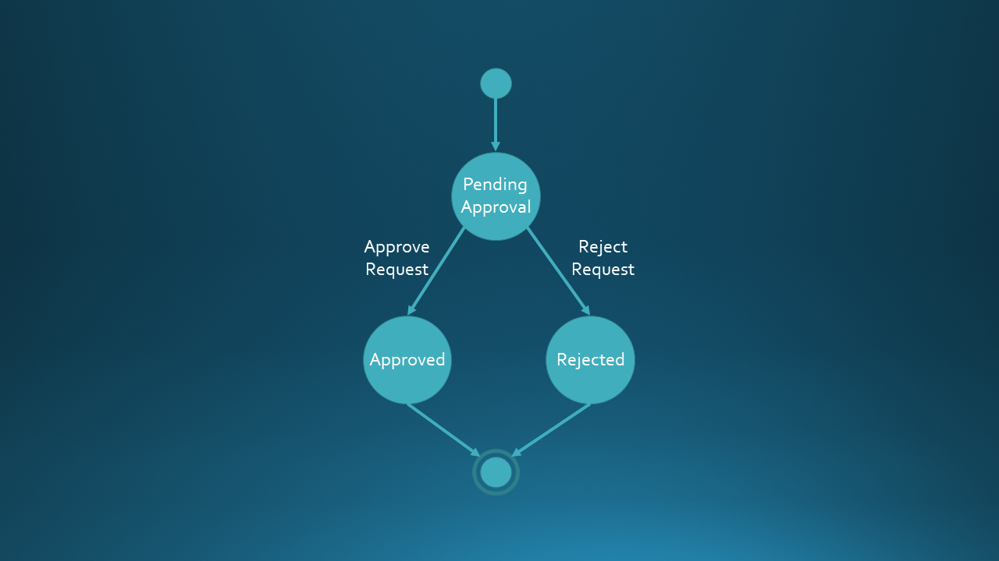

Entity-relationship diagram.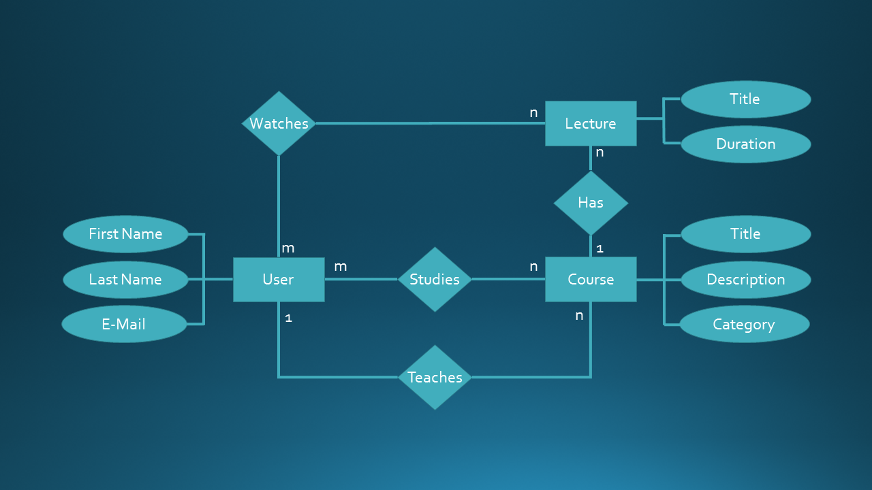
Data flow diagram for user data.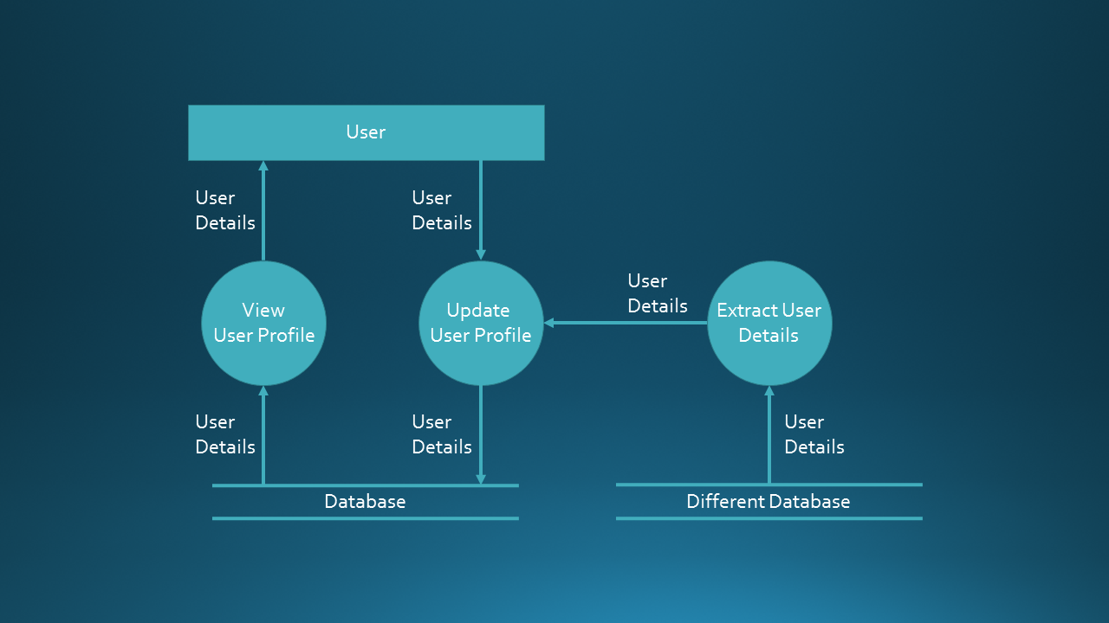

Use case diagram.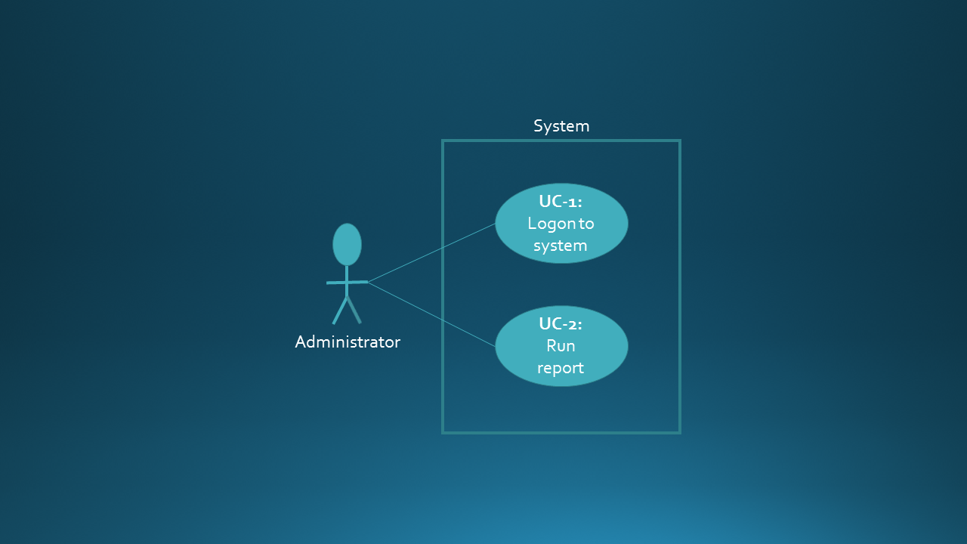

User Interface

[NOTES:
This section can be removed if you don’t design user interfaces or if your project doesn’t call for them.
If you do depict user interface designs, we recommend mentioning the level of fidelity (e.g. “High-fidelity mock-up” or “Low-fidelity wireframe”).
]

[Image title]
[Relevant commentary (optional)]
[Image]

Special Considerations

For Development
[Include any special information, not covered elsewhere, relevant to the development team. This should NOT contain requirements which should all be listed prior to this section of the document.
For example: “The project sponsor would like to see mobile screens as early as possible during the development phase.”]

For Testing
[Include any special information, not covered elsewhere, relevant to the testing team.
For example: “Please be sure to test the report generation features in particular detail, due to past quality issues.”]

For Implementation
[Include any special information, not covered elsewhere, relevant to the implementation team.
For example: “When preparing to register the DNS entries for the new website, please contact Jane Doe in Marketing. She will need to approve the URLs first.”]

For Training
[Include any special information, not covered elsewhere, relevant to the training team.
For example: “We’ve designed the report generation capability as simply as we could. However, it’s still confusing to some people, and we may need to focus training on those features.”]

